Adjective Phrase

✅ Definition:
# Source: AI Source: Provided by: [Data Path: Persons Table -> ID Column: 1, Name_En Column: Motasem Essam] -> From: [Chatgpt (GPT-4-turbo)] on [7/28/2025]
An adjective phrase is a group of words that functions as an adjective, meaning it modifies a noun or pronoun by giving more information about it.
It always contains an adjective as the head word, possibly with modifiers (before or after).

🧩 Key Features of an Adjective Phrase:
# Source: AI Source: Provided by: [Data Path: Persons Table -> ID Column: 1, Name_En Column: Motasem Essam] -> From: [Chatgpt (GPT-4-turbo)] on [7/28/2025]
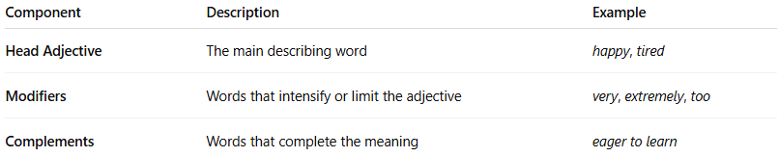
Component | Description | Example
Head Adjective | The main describing word | happy, tired
Modifiers | Words that intensify or limit the adjective | very, extremely, too
Complements | Words that complete the meaning | eager to learn

✏️ Examples of Adjective Phrases:
# Source: AI Source: Provided by: [Data Path: Persons Table -> ID Column: 1, Name_En Column: Motasem Essam] -> From: [Chatgpt (GPT-4-turbo)] on [7/28/2025]
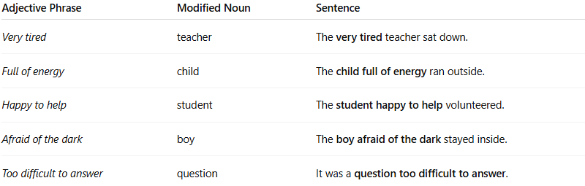
Adjective Phrase | Modified Noun | Sentence
Very tired | teacher | The very tired teacher sat down.
Full of energy | child | The child full of energy ran outside.
Happy to help | student | The student happy to help volunteered.
Afraid of the dark | boy | The boy afraid of the dark stayed inside.
Too difficult to answer | question | It was a question too difficult to answer.

🧠 Structure of an Adjective Phrase:
# Source: AI Source: Provided by: [Data Path: Persons Table -> ID Column: 1, Name_En Column: Motasem Essam] -> From: [Chatgpt (GPT-4-turbo)] on [7/28/2025]
(Intensifier/Modifier) + Adjective + (Complement)
🔹 very + happy
🔹 full + of energy
🔹 eager + to learn

🧠 Position of Adjective Phrases:
# Source: AI Source: Provided by: [Data Path: Persons Table -> ID Column: 1, Name_En Column: Motasem Essam] -> From: [Chatgpt (GPT-4-turbo)] on [7/28/2025]
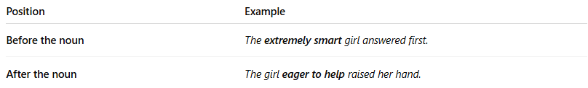
Position | Example
Before the noun | The extremely smart girl answered first.
After the noun | The girl eager to help raised her hand.
Note: Adjective phrases often follow linking verbs like be, seem, feel, look, acting as subject complements.
→ The answer seems quite obvious.

📌 Functions of Adjective Phrases:
# Source: AI Source: Provided by: [Data Path: Persons Table -> ID Column: 1, Name_En Column: Motasem Essam] -> From: [Chatgpt (GPT-4-turbo)] on [7/28/2025]
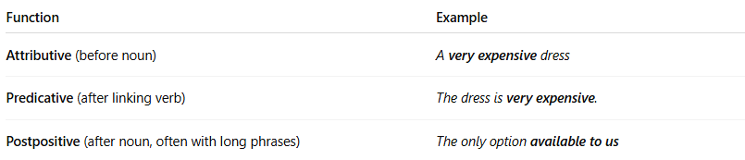
Function | Example
Attributive (before noun) | A very expensive dress
Predicative (after linking verb) | The dress is very expensive.
Postpositive (after noun, often with long phrases) | The only option available to us

🔍 Expanded Example:
# Source: AI Source: Provided by: [Data Path: Persons Table -> ID Column: 1, Name_En Column: Motasem Essam] -> From: [Chatgpt (GPT-4-turbo)] on [7/28/2025]
Sentence: The cat covered in mud looked miserable.
- Adjective Phrase: covered in mud
- Modified Noun: cat
- Head Adjective (Participle): covered
- Complement: in mud

🧠 Summary Table:
# Source: AI Source: Provided by: [Data Path: Persons Table -> ID Column: 1, Name_En Column: Motasem Essam] -> From: [Chatgpt (GPT-4-turbo)] on [7/28/2025]
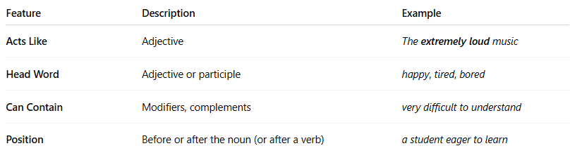
Feature | Description | Example
Acts Like | Adjective | The extremely loud music
Head Word | Adjective or participle | happy, tired, bored
Can Contain | Modifiers, complements | very difficult to understand
Position | Before or after the noun (or after a verb) | a student eager to learn

